NSW Data Skills Survey 2018

Report

Table of Contents

NSW Data Skills Survey 2018 1

1. Overview 2
1.1 Context and Background 2

2. Survey responses 3
2.1 Question 1. Where do you work? 3
2.2 Question 2 – Would you benefit from learning more about data in your role? 4
2.3 Question 3: What additional data skills and knowledge do you need? 4
2.4 Question 4: What method of learning would best meet your needs? 5
2.5 Question 5: What is the key data challenge in your role 5
2.6 Question 6: Are you a data professional? 8
2.7 Question 7: Any other comments or suggestions? 9

3. Key Findings and Recommendations 15

Overview

Context and Background
There is no asset more critical than usable, accessible data that enables insights and informs decisions. The NSW Government is committed to unlocking the full potential of the data it holds while respecting privacy requirements, and using it to drive data-informed change in legislation, policies and processes.
The NSW Digital Strategy calls for data insights to be used to improve policy and service design across NSW Government. To achieve this objective, NSW public sector staff need to have skills in finding, using, analysing and applying data in their roles and business goals.
The Department of Finance, Services and Innovation conducted a Data Skills Survey to identify the data related skills the NSW Government needs to build, and the best mechanisms for delivering these skills.
A NSW Data Skills Survey published on Survey Monkey was sent to the 8500 subscribers of Digital NSW. 1156 NSW public sector employees responded to the survey.
The survey asked users seven questions:
- Where do you work?
- Would you benefit from learning more about data in your role?
- What additional data skills and knowledge do you need?
- What method of learning would best meet your needs?
- What is the key data challenge in your role?
- Are you a data professional?
- Any other comments or suggestions?

This report provides an overview of the survey questions and responses, and outlines various recommendations for meeting data skills needs identified across the sector.

Survey responses

Question 1. Where do you work?
This question identified the number of responses received from each cluster, to help determine whether survey responses provide a cross-cluster perspective. Results show that responses were received from all clusters, with most responses received from the Education and Transport clusters.

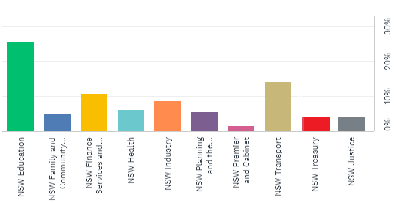
Figure 1. Where do you work?

Question 2 – Would you benefit from learning more about data in your role?
This question sought to identify whether public sector staff want to learn more about data, to assist them in their work. It received an overwhelmingly positive response, with 94% of respondents reporting that they could benefit from learning more about data in their current role.
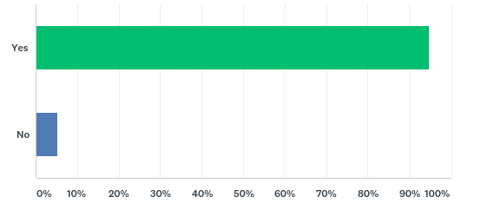
Figure 2. Would you benefit from learning more about data in your role

Question 3: What additional data skills and knowledge do you need?
People were provided with a range of options for this question, together with an option to add their own specific additional skills and knowledge requirements. Respondents could select multiple options in response.
The additional data skills and knowledge that most people nominated were ‘Using data to improve decisions and service delivery’ and ‘Finding data to help me in my work’.
Multiple Choice Answer | Responses
Using data to improve decisions and service delivery | 66.74% | 644
Finding data to help me in my work | 60.41% | 583
Creating and using data visualisations | 56.99% | 550
Understanding data governance rules | 41.45% | 400
Data privacy and security | 40.41% | 390
Data policy and legislation | 35.96% | 347
Requesting data held by another agency | 35.54% | 343
Sharing data outside of my agency | 33.58% | 324
Simple advice on what data is and how it applies to my work | 33.06% | 319
Publishing real time data | 31.09% | 300
Including data considerations in contracts and agreements | 24.04% | 232
Releasing open data | 20.73% | 200
Other (please specify) |  | 81
 | Answered | 965
 | Skipped | 191

People used the ‘other’ response to outline a range of additional skills they would like. These additional skills focussed on storytelling and communicating with data, and analysing and interpreting data:

- “We use data to tell stories. It would be great to develop more literacy and competency…”
- “Who is doing great work with mapping, visualisations etc”
- “Knowing how to tell stories from the data available”
- “Communicating complex data to the public”
- “Helping others to interpret data and use it wisely”
- “Interpreting data…using data to understand our customers - improving decisions and service delivery”
- “My team desperately needs a data analyst or persons trained with the necessary analytical skills to turn the endless data that is available into a usable product.”

Question 4: What method of learning would best meet your needs?
A broad range of learning methods and options were requested by participants. The most popular options were e-learning modules (64%) and online tools and resources (61%). Users could select multiple options in response to this question:
Multiple Choice Answer | Responses
E-learning modules | 64.64% | 637
Online tools and resources | 61.02% | 601
A classroom environment / training Course | 56.75% | 559
A collaborative online community | 26.50% | 261
Secondment | 20.61% | 203
All of the above | 10.05% | 99
University Degree | 6.19% | 61
Total Respondents: 985

Question 5: What is the key data challenge in your role
People could provide a free text response to this question. 786 responses were received. These responses have been categorised into broad themes:
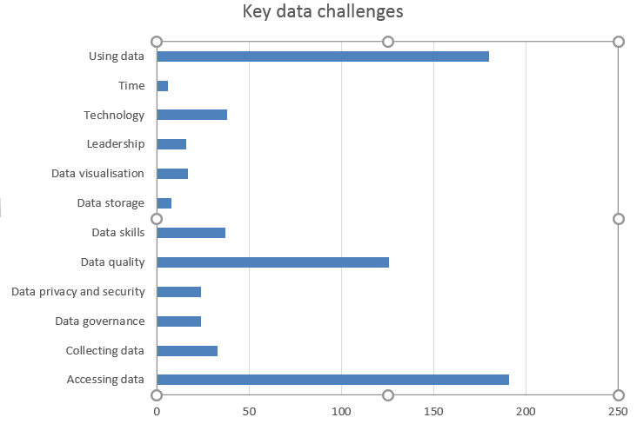
Accessing data was reported as the key challenge. People reported on a wide range of issues associated with data access including:
- “Finding and gaining access to data sets available to others in the department”
- “Getting real time up to date information, eliminating red tape and access to data to do my job”
- “Getting it; knowing the right questions to ask; knowing how to interpret it”
- “Being able to easily find the right data for testing purposes and the limitations in data we receive from other agencies”
- “Not having access to or enough data to support decision making”
- “There is not enough data to help me make decisions. I have to go and search for it, or generate them myself.”
- “Locating data sources and accuracy of data”
- “Obtaining data from other agencies”
- “Overcoming cross-agency data access issues”
- “Facilitating sharing of data between agencies”
- “Ensuring a user-friendly platform so the data can be easily accessed and interpreted”
- “Influencing other agencies to share data, obtaining data that can be processed in a way for the general public to understand (without too many caveats/baselines/technical jargon)”

Using data was the next most significant challenge reported. Key challenges reported included:
- “Understanding what the data means and being able to communicate the key message to business managers clearly and without refutability”
- “Interpreting the data we generate and having data driven policy development.”
- “Finding the right stories that people will be interested in, without having to wade through masses of different datasets”
- “Analyzing data and representing it into formats eg. charts that others can easily interpret”
- “Sorting through all the available data”
- “Using data and statistics for decision making”
- “Data analysis - interpreting data to enable good policy decisions”
- “Using client and program data to evaluate performance and outcomes”
- “Means and methods of collating usable data”
- “Understanding the data inputs/requirements/methodologies”
- “Managing, analysing, publishing and sharing data that is governed poorly through a range of disparate licensing constraints”
- “Effectively using the data we have to make better procurement/business decisions”
- “Lack of appreciation of the value of data in decision making. Decisions made with little or no evidence.
Data quality was the third most common challenge reported. Key comments provided were:
- “Single source of truth, version control”
- “Data integrity...”
- “Data quality, data stuck in old terrible systems, data and metadata not machine-readable”
- “Currency of Data in a slow moving approval landscape”
- “Data is collected when we attend jobs, however, other contributing factors, which are relevant to the data, and potential outcome, are not necessarily measured, so, it may appear skewed or be misinterpreted when used.”
- “Needing to make decisions based on data from other organisations, when that data is heavily obscured, hard to access, or presented incomplete.”
- “Currently paper based data collection with inconsistencies in how measures/ assessments are taken and reported. Data visualisation is therefore non existent”
- “Consistency of terminology and definitions, governance and change and configuration management”
- “Attention to the basic data structures is key to more glitzy uses. Understanding the complex frameworks is key”
- “People not capturing the correct data”
- “Poor quality metadata & application of governance rules”
- “Data quality when in a high pressure environment that doesn't necessarily allow for time to enable quality”
- “Data integrity; ensuring that people understand the data they are given”

Question 6: Are you a data professional?
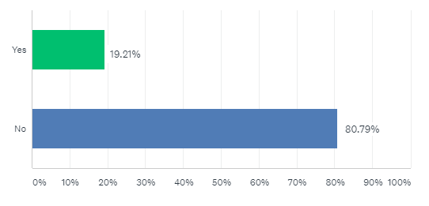
Fig.6 Are you a data professional?

This question allowed users to self-define ‘data professional’. 81% of respondents self identified as a non-data professional, showing that the survey reached an intended broad-spectrum of public sector employees.

Question 7: Any other comments or suggestions?
282 respondents submitted valuable comments to this question. Responses have been categorised into the following key themes:
- Training and resources
- Collaboration
- Leadership
- Skills
- Standards
- Technology
- Using data
Training and resources, technology and the need for standards and standardisation were the most common categories of responses.

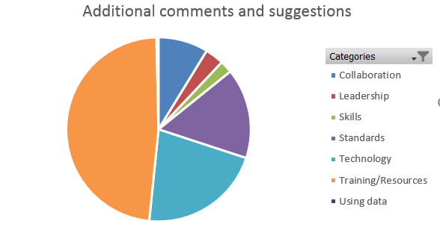
Under Training and Resources, key comments included:
- “Good initiative but this is a big task and key issues need to be prioritised!”
- “Data seems to be a very elusive thing - any help in this area would be appreciated.”
- “Keeping the initial contacts/courses simple and explaining language would be very helpful.”
- “My job is complicated enough. I would like to either use data on a daily basis or not at all.”
- “The access to tools is great, Power BI, Office 365, SharePoint, they're allowing great stuff! If more guidance material / online training was available that'd help.”
- “Facilitate some training and maybe establish a Community of Practice.”
- “Finding the right level of training/education is challenging, often the introduction to new technology/concept is too shallow or too deep.”
- “Often hard to work out in practical terms if something useful/employable in your own particular work environment. Expert consultants that can visit on site for 2-3 days could fill the gap, without the administration of procurement.”
- “Because of the main focus on data at the moment - when data personnel are contacted for assistance there is often a resistance to look at new requests due to the demands on their time and also because staff want to be the custodians of data sets and not keen to release data that can assist decision making in projects.”
- “I would strongly welcome face-to-face and online training in the topics identified in this survey - especially the analysis of data and the use of data in presentations, graphs, etc. Thank you!”
- “The more awareness and availability the better.”
- “Training and development in this field would be immensely useful for my current, and hopefully future, roles. Additionally, we have an extremely high need for valuable data right now, and this need will grow as we change the work environment our teams exist in.”
- “A lot of the terms used assume a specific understanding, e.g. what do we mean by data governance VS data sharing and privacy rules? What is a data professional? We don’t necessarily have a common understanding of those terms, would have been good to define them.”
- “Would be great to have some case studies of how data can be used in policy making.”
- “Need more money for "real training" for anyone who wants to be trained in using data. This should be a long term strategy. Not just 1 or 2 year strategy.”
- “Rural and remote locations need as easy access to any professional learning courses as those in big centres. Big centres could come to rural and remote locations for a change. Online learning is not always successful due to poor internet service.”
- “Information that I can have access to when I need it. Waiting a month or two for a training course then not having the opportunity to apply what I've learned for a few weeks after the course isn't helpful.”
- “Simple excel macro tools workshops and automation classes could result in productivity gains.”
- “Keep it simple.”
- “Make it mandatory for managers.”
- “The sooner the better.”
Technology was the second most common category of response. People said that:
- “Ensure departments provide databases that are user friendly, relevant to the nature of the work we do and are able to produce (easily) reports that provide relevant information back to us in the workplace.”
- “Access to computers is the biggest struggle.”
- “Systems should be built to cater for users to easily extract basic (at the minimum) data. We are in the planning stages of a new system but it seems data will still be confined to those with knowledge and access to the tables.”
- “NSW Government agencies should make it easier to update and improve customer interfaces.”
- “Big whole of government platforms need to give options of historical data viewing.”
- “Ensure SSO operates seamlessly across all data collection and reporting platforms.”
- “Limiting employees access to data tools limits the entire department.”
- “We have copious amounts of data, but very ad hoc storage systems. We need to invest in data storage and access.”
The third most common category of response was standardisation. People said:
- “It would be good to have data reports and visualisation standardised across the Department to avoid duplication.”
- :How do we drive a consolidated data governance strategy across all of NSW Gov?”
- “Universal NSW government data governance guidance will be most welcome.”
- “There are many tools for data visualisations in various applications which is great, there is communities of use building which is even better, but ultimately data quality is a big issue - to be fair most of the data I'm looking at is regarding internal service delivery rather than data from sensors or automated processes - further automation in human-computer interfaces would be great to ensure more compliance in routine tasks”
- “It would be great if there was a more consistent approach to open data.”
- “If team specific data were available in real time, work could be managed actively and independently by team members with minimal supervision”
- “Accurate real-time data will improve the level of decision making!!”
- “Data systems that provide standardizing schema for different types of data will allow the leveraging of data. The location attributes for economic data is often inadequate to assign the use of natural resource use.”
- “Critical data access and integrity have been compromised by recent transfers to different databases administered outside the agency of core data users.”
- “Agencies should be required to share data with each others so there should be some conventions imposed to ensure ease of sharing (Privacy protected)”
- “We need to understand what data we need to own the collection of and what data we can get/buy from external sources and invest accordingly in data.”
Respondents also flagged that skills and training alone are insufficient to improve the use of data across the sector. Leadership and a commitment to training at a senior level is also necessary to achieve these outcomes. Respondents commented that:
- “Gaining a commitment from management / leadership to drive change (data culture)”
- “Ensure all levels of staff understand data”
- “Ensuring data is valued as an asset”
- “A lot of business managers, coordinators, & people that should be using data every day, fail at simple excel & data manipulation tasks. They don't have enough computer literacy skills to even begin interacting with data”.
- “Change culture of the organisation to understand that Data Quality is important, and doesn't come without commitment.”
- "NSW Government are really falling short with how they are running their day to day activities. Technology is such a big part of how we should be operating, some places are still very old school and struggle to have made a transition from old ways of working (pre computer days) The government really needs to step up its game on this."
- "IT" and data are tools and not the solution on its own. We need to get the balance right and use IT and data to support our business and drive the required outcomes. All that is happening now is the drive for IT and data as the sole solution and its creating significant inefficiencies and frustration.”
- “Data and IT is not a panacea, they are source materials and tools to support the business. They have limitations and cannot tell the whole story. The translation from data to knowledge and action needs to be understood within the wider policy context.”

Improved collaboration and coordination of data initiatives was also identified as a requirement.
- “Every part of my work involves data. However, it is not easy or simple to know what to ask for or who to contact for help and advice.”
- “I think an online community would be a good way to back up the classroom environment and e-learning modules as it will help to ensure what's learnt is not only remembered but becomes part of BAU.”
- “Our business has enormous potential for using data well at all levels… The challenge isn't technical - it's making allies of management and coders, because they have so much to offer each other.”
- “Make data easier to find and use”
- “A community to share and collaborate”
- “Build a community within the NSW government to share and collaborate with likeminded professionals. A thought leadership initiative would be great”
- “Management often does not know what the coders could produce for them - they don't know how to ask. Coders don't have the day-to-day feel of the work - they wouldn't know what to offer. Mingle the groups. Get them talking. Everyone - from customer to minister - will benefit.”
People also requested strong policy guidance around data:
- “I would like to have guidelines around standards to integrate our data with other agencies”
- “If another organisation (inside or outside government) obtains DFSI data, can they use it?”
- “When we can share across government and when we can't as I feel that's a murky area”
- “Should (private sector) data be used for policy development, decision making?”
- “…What data is available, how to access the data and what data we can share with whom”
- “Formalised documentation of accepted work processes when dealing with data.”

People said that they would like access to practical support and advice to help them as part of business as usual, to build a data practice:
- “A mentor to meet with regularly for data advice and to act as a point of contact for questions”
- “A go to person / coach or mentor who can quickly resolve or help Hotline number or query”
- “A list of key contacts or communication & support lines to people with more advanced data skills.”
- “Expert consultants that can visit on site for 2-3 days could fill the gap, without the administration of procurement”
- “Secondment-lite: buddy up with people for a half a day to discuss their work”
- “It would be extremely useful to have a single team that sits within NSW govt that can consider all requests for data before individual agencies instigate new data collection. This would reduce duplication and increase efficiency. All agencies should be required to provide data held to this team to create a data warehouse. The team could identify data gaps that exist through requests for data and commission research to fill these gaps, potentially meeting the needs of multiple requests from agencies in a single activity.”
- “Presentations given by current users of data in NSW Government or perhaps outside of the sector. Examples may include: Data Analytics Centre, Behavioural Insights Unit, Economic Forecasting Division, Australian Bureau of Statistics, etc.”
- “External site visits and short course inter-departmental training with experienced staff/trainers”

Key Findings and Recommendations

A wealth of useful information was provided through the Data Skills Survey. The valuable insights provided through the Data Skills Survey will help to shape whole of government strategies and directions for data and data skills.
No. | Finding | Recommendation | Action | Due
1. | 94% of respondents (1087 people) from across all clusters in the sector say they would benefit from learning more about data in their role. 80% did not identify as a data professional.  Capability improvement, leadership and strategic oversight is needed to drive increased data skills and use in government, and consequent service improvement. | 1a) Share survey report with Public Service Commission and Customer Service Commission and collaborate on next steps with these groups.  1b) Further develop the data policy and practice environment in DFSI to provide whole of government strategy and direction for data skills improvement across the sector.  1c) Develop and drive a strategic data implementation plan for NSW government  1d) Establish the Data Champions Network and include Senior Executive Data Sponsors in the Data Champions Network, to help promote and support data initiatives. | DFSI to take lead role in data education for NSW public sector and collaborate with data professionals in NSW governmnet to design and build a data practice.  DFSI to share Data Skills Survey Report with PSC and CSC.  DFSI and DAC to co-develop strategic NSW data implementation plan prototype, for broader consultation across the sector.  DFSI to establish the Data Champions network and include Senior Executive Data Sponsors. | 2019
2. | People want to use data to improve decisions and service delivery, and want to find data to help them in their work.  Key challenges reported by respondents were: finding and accessing data (reported by 24% of respondents); using data (23%); and  data quality (16%)  These challenges will each require skills, technology and cultural improvements. | 2a) Data skills initiatives need to focus on building capabilities for improved decision making and service delivery.  2b) Work with data custodians and data users to workshop skills and guidance options that can help to resolve data access, use and quality issues.  2c) Utilise DFSI’s dMarketplace program as a mechanism to help public sector employees find the data they require for their work.  2d) Use the NSW data policy and practice environment in the dMarketplace program to help enable effective agency data sharing.  2e) Convene collaborative agency workshops to identify issues with data quality and options for their remediation.  2f) Develop or identify and promote training resources to help agencies improve data quality data. | DFSI to design skills strategies and approaches that help data to be used to improve decision making and service delivery.  DFSI to run design workshops on data access, use and quality issues.  In collaboration with the sector, DFSI to utilise the dMarketplace program to help find and use the data they need in their roles.  DFSI to address barriers and improve skills associated with accessing and using data, and issues with data quality. | 2019
3. | People want assistance to use data for storytelling and communicating about their work and potential needs and improvements, and want assistance in analysing and interpreting data. | 3a) Prioritise the development of case studies showing how government agencies are using data to improve decisions and service delivery, and publish these on Digital NSW.  3b) Build and maintain user-friendly data guidance, use cases and case studies about data and data use. The range of content should show the value of data and be useful for all users, from those new to data and digital through to more advanced professionals. Advice should be published on Digital NSW.  3c) Build and maintain advice and case studies about the use of data analysis and methods of data interpretation used in government. | DFSI to liaise with colleagues across the sector to publish a range of case studies and guidance on Digital NSW.  DFSI to work with DAC to develop and publish case studies about data analysis. | 2019
4. | People want ongoing, accessible, scalable learning that is the right fit for their level of expertise and aligns with a wide range of learning preferences.  People want multi-modal learning options: e-learning modules (64%); online tools and resources (61%); classroom learning 57%.  Training needs to have a practical focus, be applicable to a range of skill levels and not be a one-off. Data will be a long term tool and asset in government and so a long term approach to data skills and training is required. | 4a) Develop or identify and promote potential online resources, e-modules and class room training, collaborative online environments via Digital NSW, that align to identified data needs.  4b) Ensure all guidance and training developed supports a wide range of user needs and skill levels. A range of training and guidance should be written in plain English and be suitable for non- specialist/technical roles. | DFSI to explore options for designing and delivering data training content to NSW public sector employees | 2019
5. | Current technology in government isn’t consistently designed to support data creation, data use and insights generation. Standardised government tools like visualisation technologies can improve use data of data insights. | 5a) Work with NSW Procurement to identify contract opportunities to improve whole of government data access issues, for example through options such as requiring all systems provide data extract capabilities, or ensuring access to historic data is a standard component of service offerings.  5b) Investigate common offerings used in government for visualisation. | DFSI to work with NSW Procurement to identify potential systemic opportunities to improve data access.  DFSI to partner with agencies to identify visualisation tools.
6. | Additional policy and guidance will be useful to support data practice, use and improvement.  Increased standardisation is needed in data management approaches, data governance and real time data availability. | 6a) Test prototypes from Data Policy Sprint that support data practice, use and improvement.  6b) Run a workshop with NSW Data Champions Network to identify key requirements for data governance in NSW public sector. Use this collaboration and learnings to develop a NSW data governance policy and associated requirements. | DFSI to test data sprint prototypes.  DFSI to run data governance workshop. | 2019
7. | Increased data collaboration and data mentorship across the sector can help drive data change and improvement. | 7a) Develop, support and engage the Data Champion Network to identify multiple levers of influence to build and sustain a collaborative data community.  7b) Continue to use Digital NSW channel to promote case studies, data initiatives and data lessons learned to help build NSW data practice and data skills improvement.  7c) Build a data practice team to help agencies do more with their data. | DFSI to convene Data Champions Network to enable cross-agency solution and community building, and to invest in data-related storytelling.  DFSI to use Digital NSW to promote data skills and data use in NSW government.  DFSI to build a Data Practice team to support agency data initiatives. | 2019

